EC-467 Mobile Application Development

BS (CE)-2021 LAB REPORT #4
Submitted By:

Reg. No. | Name
21-CE-009 | Huzaifa Shahbaz

Department of Computer Engineering
HITEC University Taxila
 | Presentation  (Format(0.5)+  Title (0.5)+  Conclusion(1)  +Procedure(2)  +Objective(1)) | Calculation/ Coding | Observation/  Program Results | Total
Total | 5 | 5 | 5 | 15
Obtained

Lab Instructor.
Dr. Muhammad Bilal

LAB REPORT #4
Multiple Activity and Intents
Introduction:
An Intent is a simple message object that is used to communicate between android components such as activities, content providers, broadcast receivers and services. Intents are also used to transfer data between activities. Android application components can connect to other Android applications. This connection is based on a task description represented by an Intent object. Intents are asynchronous messages which allow application components to request functionality from other Android components. Intents allow you to interact with components from the same applications as well as with components contributed by other applications. For example, an activity can start an external activity for taking a picture.

Tools:
Android Studio Iguana

Class Task:
Student Form:
XML CODE OF MAIN ACTIVITY:

<?xml version="1.0" encoding="utf-8"?>

<LinearLayout
xmlns:android="http://schemas.android.com/apk/res/android" xmlns:tools="http://schemas.android.com/tools" android:layout_width="match_parent" android:layout_height="match_parent"
android:orientation="vertical" android:padding="10dp">

<TextView
android:id="@+id/tv_Home" android:layout_width="wrap_content" android:layout_height="wrap_content" android:text="Enter Data" android:textSize="30sp" android:layout_marginTop="100dp"
android:layout_marginBottom="20dp"
/>
<EditText android:id="@+id/et_Name" android:layout_width="match_parent" android:layout_height="40dp" android:hint=" Name" android:background="#fff"
android:lines="1"
/>
<EditText android:id="@+id/et_FatherName" android:layout_width="match_parent" android:layout_height="40dp" android:background="#fff" android:layout_marginTop="10dp" android:hint=" Father's Name"
android:lines="1"
/>
<EditText android:id="@+id/et_Reg" android:layout_width="match_parent" android:layout_height="40dp" android:background="#fff" android:layout_marginTop="10dp" android:hint=" Reg #"
android:lines="1"
/>
<EditText android:id="@+id/et_CGPA" android:layout_width="match_parent" android:layout_height="40dp" android:background="#fff" android:layout_marginTop="10dp" android:hint=" CGPA" android:lines="1"
/>
<EditText android:id="@+id/et_Semester" android:layout_width="match_parent" android:layout_height="40dp" android:background="#fff" android:layout_marginTop="10dp"
android:hint=" Semester"
android:lines="1"
/>

<Button
android:id="@+id/btn_Save" android:layout_width="wrap_content" android:layout_height="wrap_content" android:layout_marginTop="25dp" android:background="#fff" android:text="Save"
android:textSize="20sp"
/>

</LinearLayout>

Java Code OF MAIN ACTIVITY:
package com.huzaifashahbaz.intentapp; import android.content.Intent; import android.os.Bundle; import android.view.View; import android.widget.Button; import android.widget.EditText; import androidx.activity.EdgeToEdge; import androidx.appcompat.app.AppCompatActivity;
import androidx.core.graphics.Insets; import androidx.core.view.ViewCompat; import androidx.core.view.WindowInsetsCompat; public class MainActivity extends AppCompatActivity {
@Override
protected void onCreate(Bundle savedInstanceState) {
super.onCreate( savedInstanceState ); setContentView( R.layout.activity_main );
EditText editTextName, editTextFatherName, editTextReg, editTextCGPA, editTextSemester;
Button btnSave;
editTextName = (EditText) findViewById(R.id.et_Name); editTextFatherName = (EditText) findViewById(R.id.et_FatherName) ; editTextReg = (EditText) findViewById(R.id.et_Reg); editTextCGPA = (EditText) findViewById(R.id.et_CGPA); editTextSemester = (EditText) findViewById(R.id.et_Semester); btnSave = findViewById(R.id.btn_Save); btnSave.setOnClickListener(new View.OnClickListener() { public void onClick(View v) {
String name, fname, reg, cgpa, semester; name = editTextName.getText().toString(); fname = editTextFatherName.getText().toString(); reg = editTextReg.getText().toString(); cgpa = editTextCGPA.getText().toString(); semester = editTextSemester.getText().toString();
Intent intObj = new Intent( MainActivity.this, NextActivity.class );
intObj.putExtra( "USERNAME", name ); intObj.putExtra( "FATHERNAME", fname );
intObj.putExtra( "REG", reg ); intObj.putExtra( "CGPA", cgpa ); intObj.putExtra( "SEMESTER", semester );
startActivity( intObj );
}
});
}
}

Results:
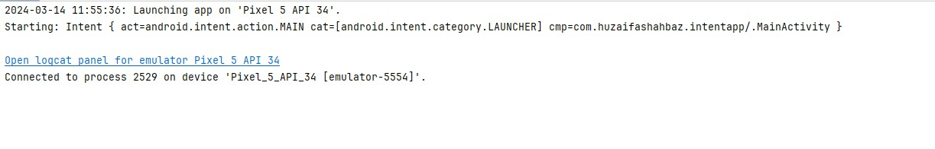 OUTPUT:
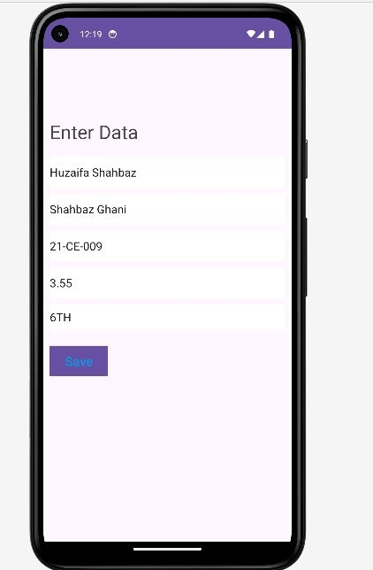

JAVA CODE OF NEXT ACTIVITY:
package com.huzaifashahbaz.intentapp; import android.os.Bundle; import android.widget.TextView; import android.content.Intent; import androidx.activity.EdgeToEdge; import androidx.appcompat.app.AppCompatActivity;
import androidx.core.graphics.Insets; import androidx.core.view.ViewCompat; import androidx.core.view.WindowInsetsCompat; public class NextActivity extends AppCompatActivity{
TextView txtName, txtFatherName, txtReg, txtCGPA, txtSemester; protected void onCreate(Bundle savedInstanceState) { super.onCreate(savedInstanceState); setContentView(R.layout.activity_next);
txtName = (TextView) findViewById(R.id. textviewName) ; txtFatherName = (TextView) findViewById(R.id. textviewFatherName) ; txtReg = (TextView) findViewById(R.id. textviewReg) ; txtCGPA = (TextView) findViewById(R.id.textviewCGPA); txtSemester = (TextView) findViewById(R.id. textviewSemester) ;
Intent getintObj = getIntent();
String uname = (String) getintObj.getStringExtra("USERNAME");
String fname = (String) getintObj.getStringExtra( "FATHERNAME");
String reg = (String) getintObj.getStringExtra( "REG");
String cgpa = (String) getintObj.getStringExtra( "CGPA"); String semester = (String) getintObj.getStringExtra( "SEMESTER"); txtName.setText (uname) ; txtFatherName. setText (fname) ;
txtReg.setText (reg); txtCGPA. setText (cgpa);
txtSemester.setText (semester) ;
}
}
XML CODE OF NEXT ACTIVITY:

<LinearLayout
xmlns:android="http://schemas.android.com/apk/res/android" xmlns:tools="http://schemas.android.com/tools" android:layout_width="match_parent" android:layout_height="match_parent" android:padding="10dp" android:orientation="vertical">

<TextView
android:id="@+id/textoutput" android:layout_width="wrap_content" android:layout_height="wrap_content" android:layout_marginTop="50dp" android:text="Output Screen" android:textSize="30sp" android:textColor="#000"/> <TextView android:id="@+id/textviewName" android:layout_width="wrap_content" android:layout_height="wrap_content" android:textSize="20sp" android:text="Huzaifa Shahbaz"
android:layout_marginTop="20dp"
/>

<TextView
android:id="@+id/textviewFatherName" android:layout_width="wrap_content" android:layout_height="wrap_content" android:text="Shahbaz Ghani" android:textSize="20sp"
android:layout_marginTop="20dp"
/>
<TextView android:id="@+id/textviewReg" android:layout_width="wrap_content" android:layout_height="wrap_content" android:text="21-CE-009" android:textSize="20sp"
android:layout_marginTop="20dp"
/>
<TextView android:id="@+id/textviewCGPA" android:layout_width="wrap_content" android:layout_height="wrap_content" android:textSize="20sp" android:text="3.55"
android:layout_marginTop="20dp"
/>
<TextView android:id="@+id/textviewSemester" android:layout_width="wrap_content" android:layout_height="wrap_content"
android:text="6th" android:textSize="20sp" android:layout_marginTop="20dp" />

</LinearLayout>
Results:

OUTPUT:
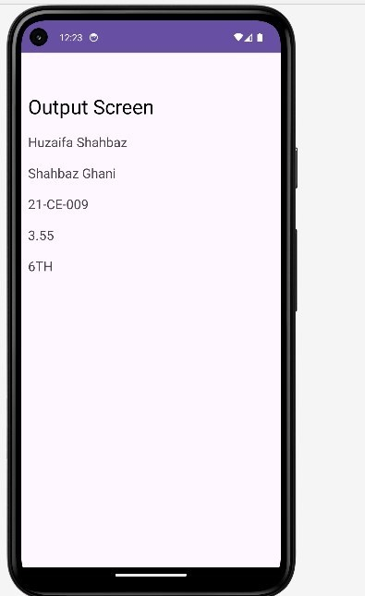

Home Task:
Design a simple login app to check entered username and password, if user entered wrong user name or password then show Toast message “You have entered wrong user name or password”, on successful entering the user name and password, bring to home page.

XML CODE OF LOGIN ACTIVITY (STUDENT FORM):
<LinearLayout xmlns:android="http://schemas.android.com/apk/res/android" xmlns:app="http://schemas.android.com/apk/res-auto" xmlns:tools="http://schemas.android.com/tools" android:layout_width="match_parent" android:layout_height="match_parent" android:orientation="vertical" android:padding="16dp" tools:context=".MainActivity">
<EditText android:id="@+id/usernameEditText" android:layout_width="match_parent" android:layout_height="wrap_content" android:hint="Username" android:minHeight="48dp" />
<EditText android:id="@+id/passwordEditText" android:layout_width="match_parent" android:layout_height="wrap_content" android:hint="Password" android:inputType="textPassword" android:minHeight="48dp" />
<Button android:layout_width="wrap_content" android:layout_height="wrap_content"
android:text="Login"
android:onClick="login"
/>
</LinearLayout>

JAVA CODE OF LOGIN ACTIVITY (STUDENT FORM):
package com.huzaifashahbaz.intentapp; import android.content.Intent; import android.os.Bundle; import android.view.View; import android.widget.EditText; import android.widget.Toast; import androidx.activity.EdgeToEdge; import androidx.appcompat.app.AppCompatActivity;
import androidx.core.graphics.Insets; import androidx.core.view.ViewCompat; import androidx.core.view.WindowInsetsCompat; public class MainActivity_studentform extends AppCompatActivity { private static final String
CORRECT_USERNAME="huzaifashahbaz786";
private static final String CORRECT_PASSWORD="21CE009";
@Override
protected void onCreate(Bundle savedInstanceState) { super.onCreate(savedInstanceState); setContentView( R.layout.activity_main_studentform );
}
public void login(View view){ EditText
usernameEditText=findViewById(R.id.usernameEditText);
EditText
passwordEditText=findViewById(R.id.passwordEditText);
String enteredUsername=usernameEditText.getText().toString();
String enteredPassword=passwordEditText.getText().toString();

if(enteredUsername.equals(CORRECT_USERNAME)&&enteredPasswo
rd.equals(CORRECT_PASSWORD)){
Intent intent=new Intent(this,MainActivity.class); startActivity(intent);
finish();
}else{
Toast.makeText( this, "You have entered wrong username or password", Toast.LENGTH_SHORT ).show();
}
}
}
Result:
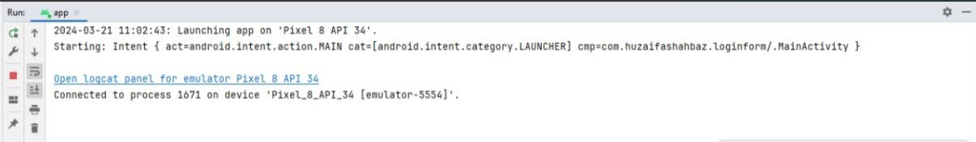

OUTPUT:

CONCLUSION:
In conclusion, we had done the intent app by making student’s registeration form and login id.By the help of java and xml.

